2024

Practical Assignment Phase 3

OLIVIE BERGERON

41068227

Evidence of Learning:

Here we have a model where we check if the validity if the data is in a good structure to be pushed to the database. The data structure needed is shown below:

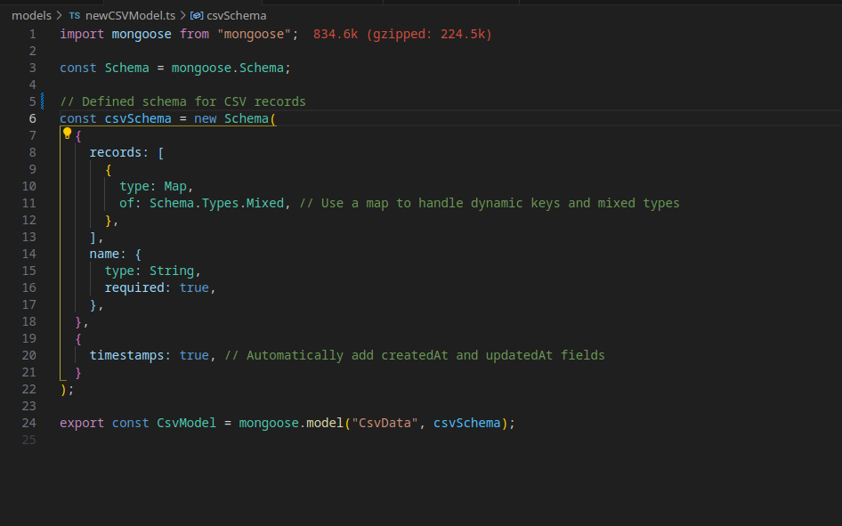

I added connectivity to Mongodb by adding calls in my route functions here is the simplest function as an example. It uses the find function and the CsvModel shown above to look into the collection/table (CsvData) to find and sort according to the createdAt time and sends that data to 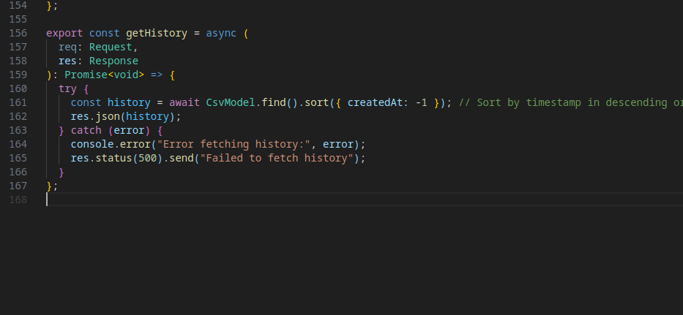the user.

I was also require to add a connection in my main app.ts to connect to my MongoDB instance:

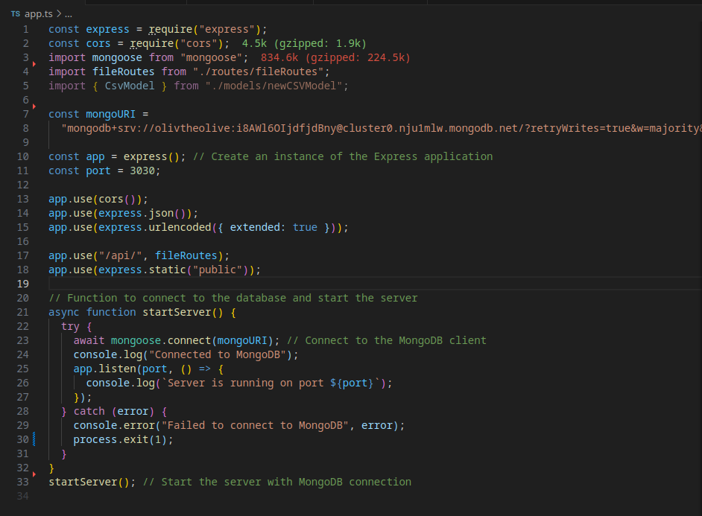This part is pretty straightforward, I provide my URI connection string in the mongoose connect function, and my app is connected to the database.

# Program Changes:

Structure wise, nothing much has changed. I kept the MVC structure that I have implemented last phase. Modified some of the file and created a new file.

# Program Demonstration via Screen Shots:

Load the page:

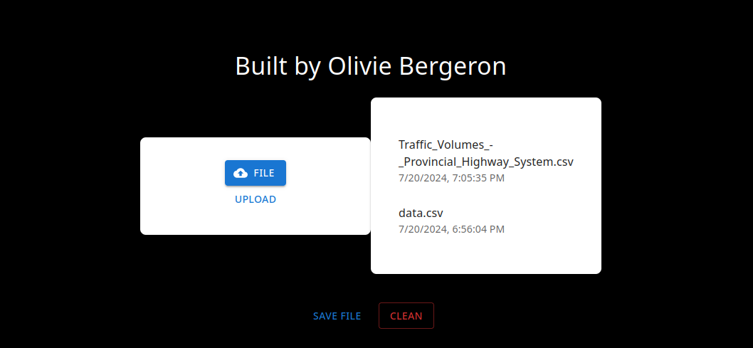

Load data will upload the data to the database and will update the database:

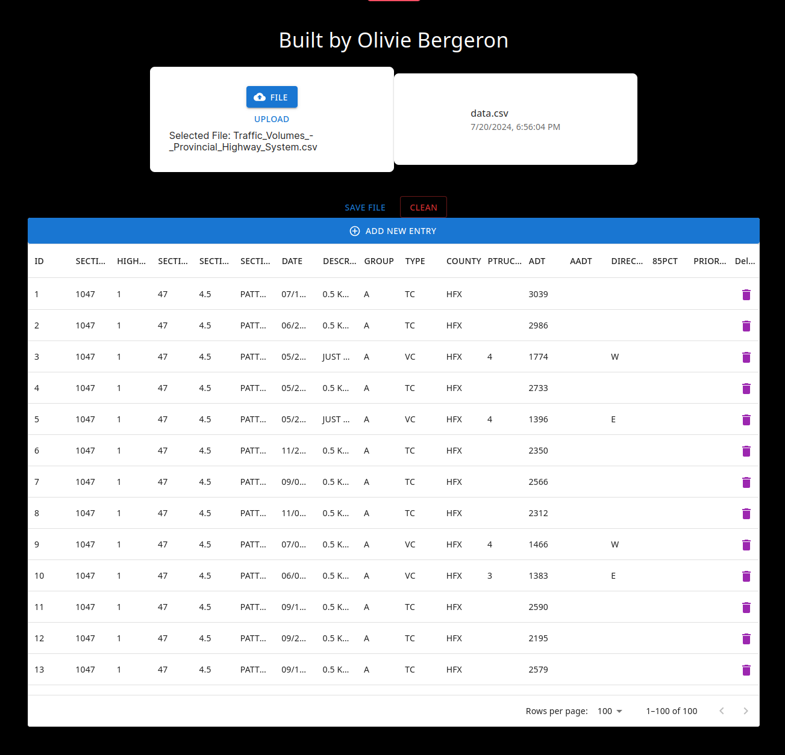

Saving the data will update that collection in the database and will show on the history window on page reload:

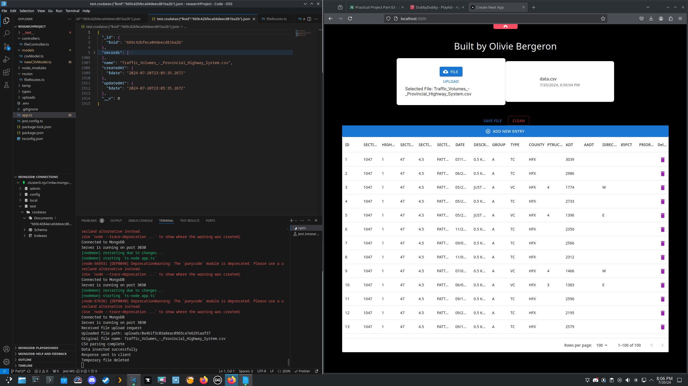2 entries in the database:

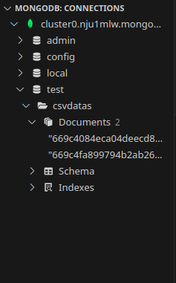

I can also reload previously added file by clicking the list on the top right this is Traffic:

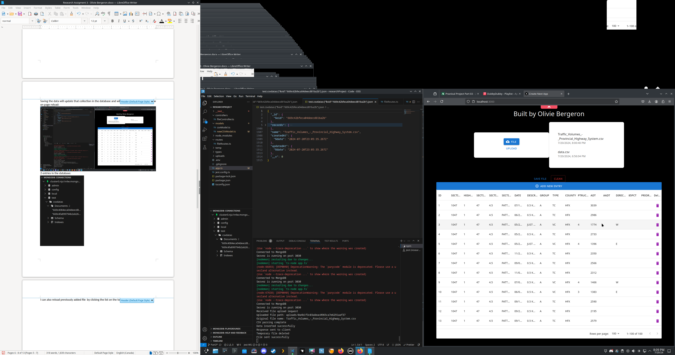

This is data.csv:

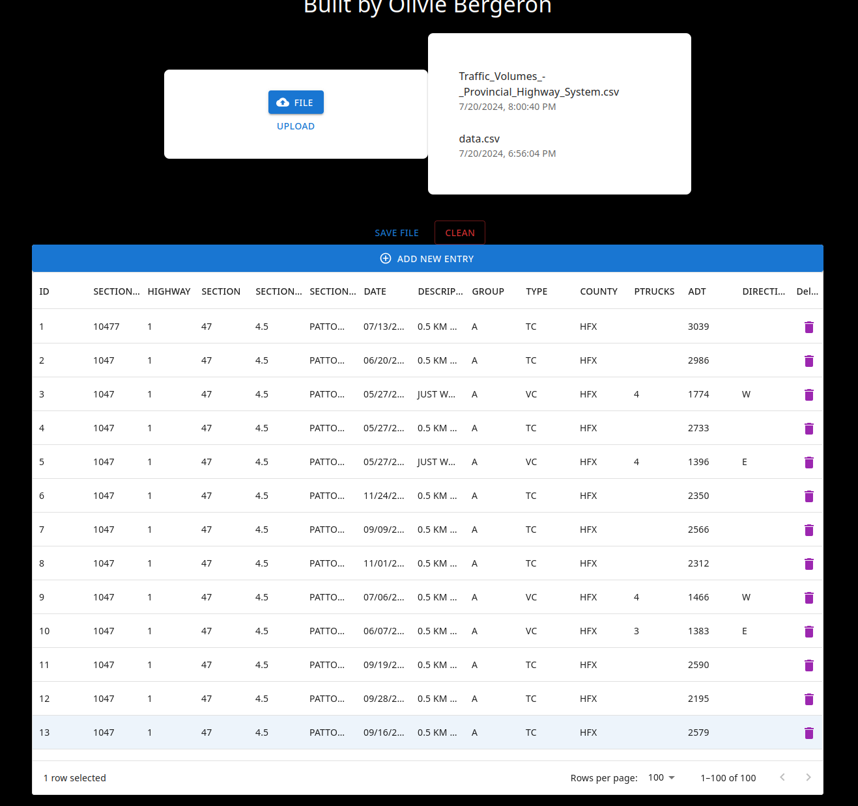

Proof that the data is stored on the database:

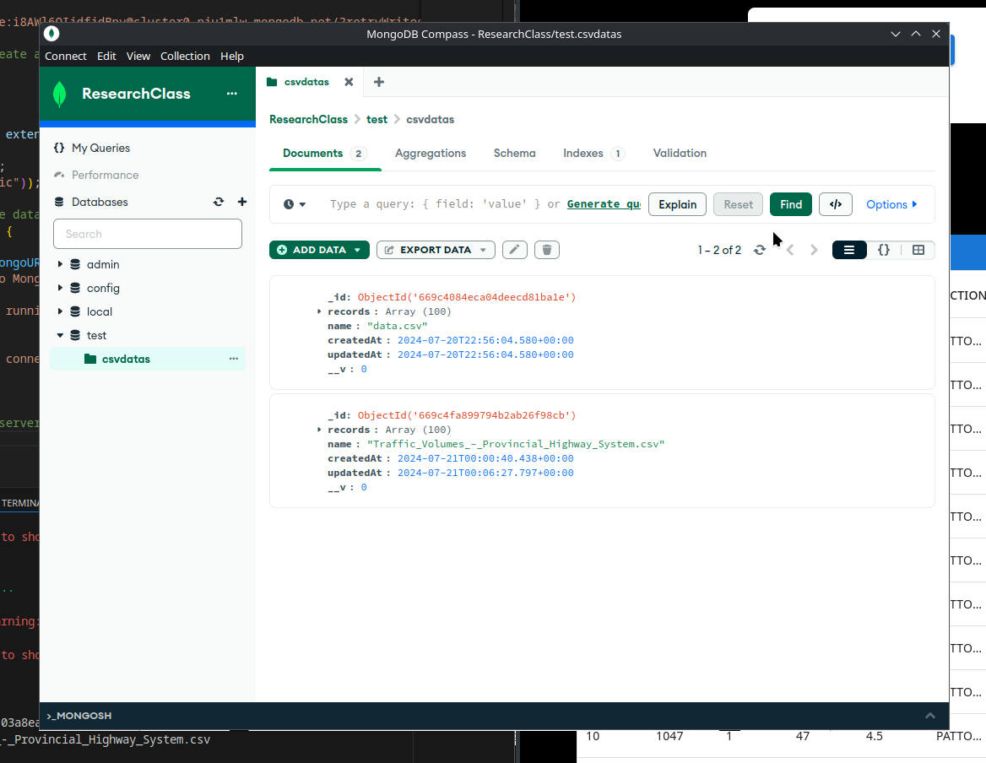

# Unit Testing Demonstration via Screen Shots:

# Source Code Commenting Example: